Test Number | Test Case Type | Description | Test Steps | Test Data | Expected Results | Actual Results | Status  (Pass/Fail)
1 | Usability | Comprehensive testing of all help features throughout the application to ensure context-sensitive help works correctly. | Test help from main menu  Test help during customer creation process  Test help from customer portal  Test help during account actions | Main Menu: Select option 4  Customer Creation: At each step where help is available, select help option  Customer Portal: Select help from portal menu  Account Actions: Select help when viewing/ opening accounts | Help should provide context-sensitive information for each menu. Should display relevant information and allow user to return to previous screen with “Press Enter to continue”. | The program had smooth transitions to help menus and each section provided brief contextual information. The Enter key allowed me to go back to the initial menu screen easily but would require another Enter key a few times. | Pass
2 | Documentation | Verify all help screens contain correct, up to date information relevant to their context | Access help from every available context  Document what help information is displayed  Verify against expected functionality | - Main menu  - Customer portal  - List customer accounts  - Select accounts  - Open account  - Create account  - Sign up  - Switch customer  - Photo ID  - Address verification  - Customer confirmation  - Open account after signup | Each help context should display information specific to that menu. Information should be accurate and helpful for user navigation | The program had contextual help information accurate to the menu scenario and helped with navigation | Pass
Testing Notes:
This section here is to provide description that gives clarity to any glaring issues that needs addressing, information not applicable for the table and useful advice needed.
Test Number 1
Step 1 | Main menu help:
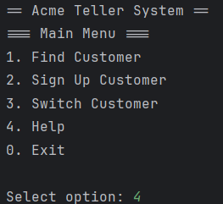
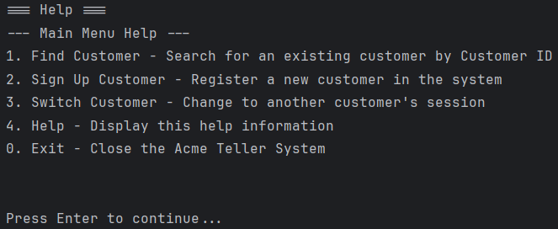

Step 2 | Customer Creation Help:
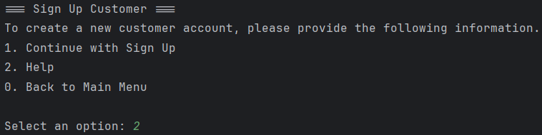
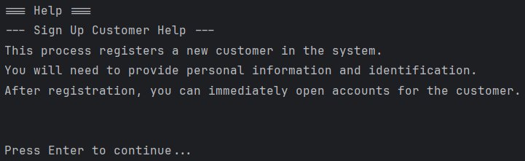
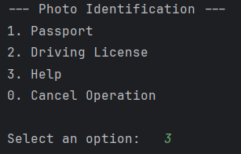
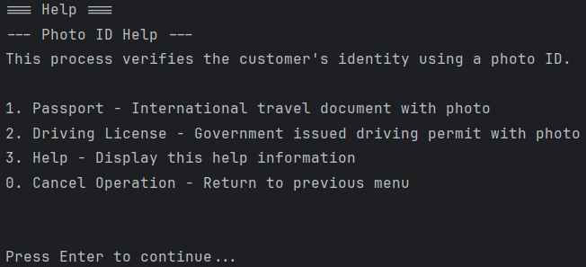
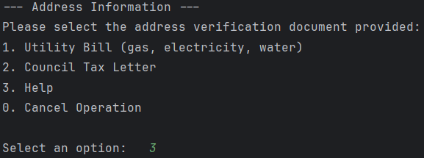
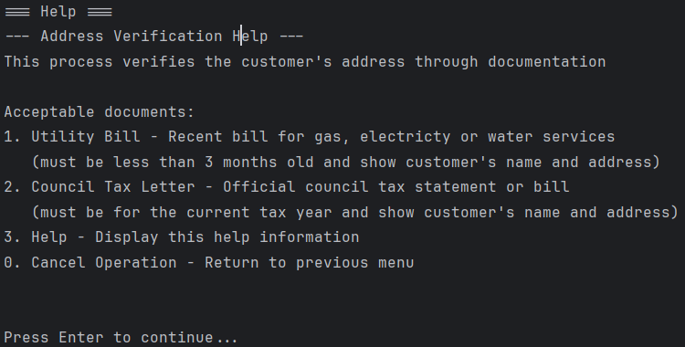
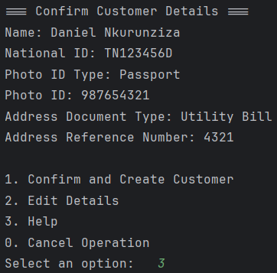
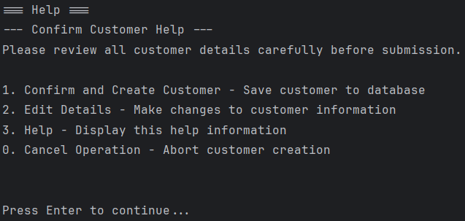
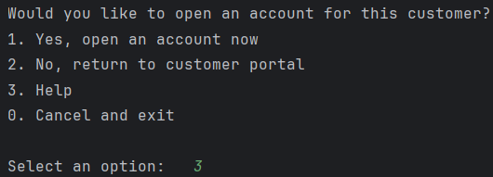
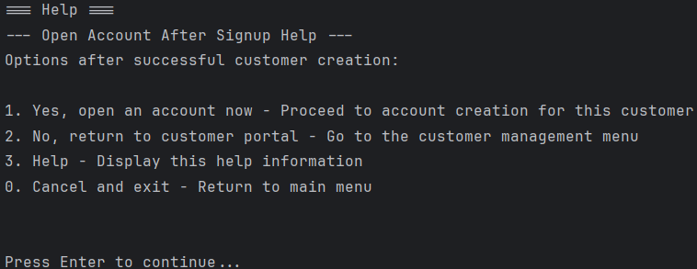
Step 3 | Customer Portal Help:
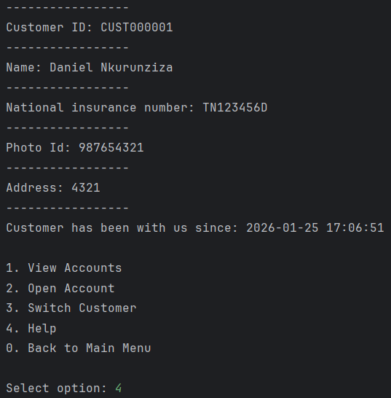
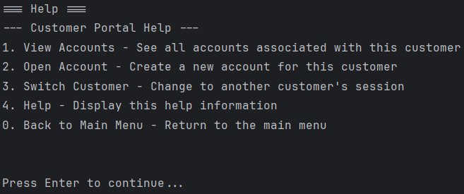
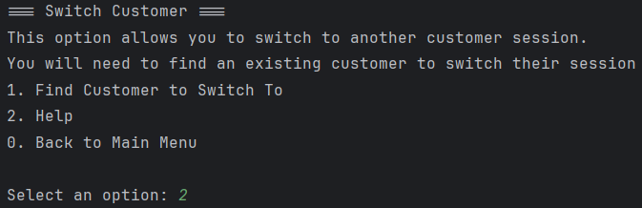
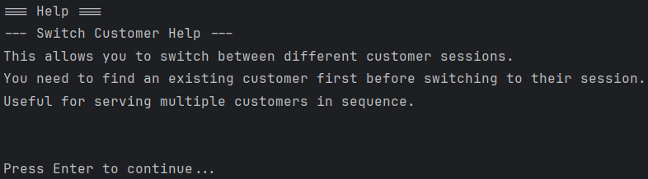
Step 4 | Account Actions Help:
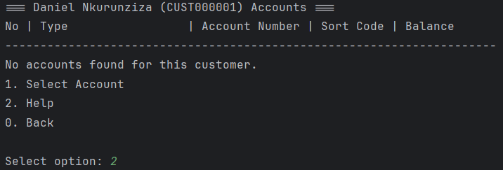
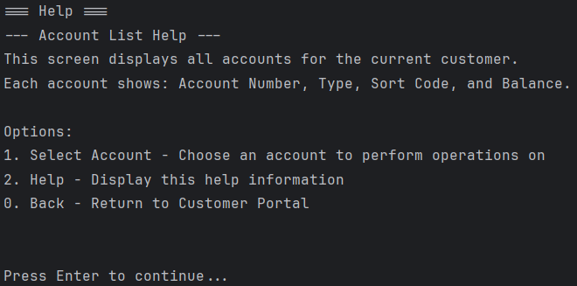
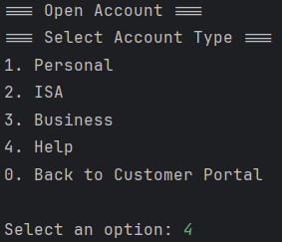
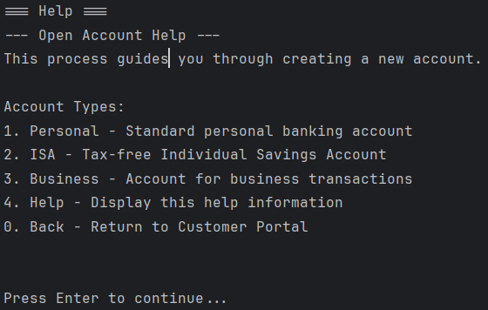
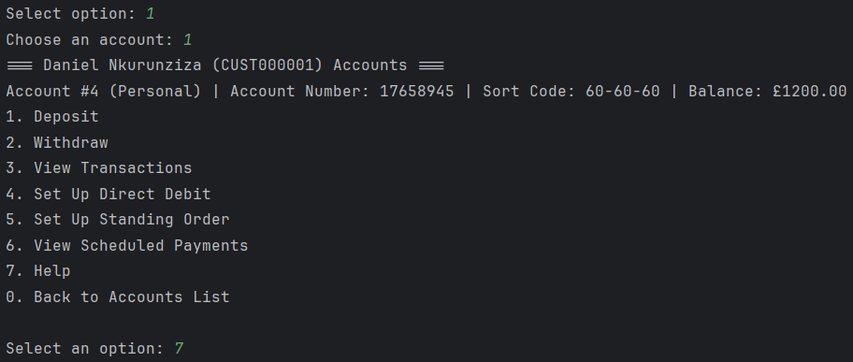
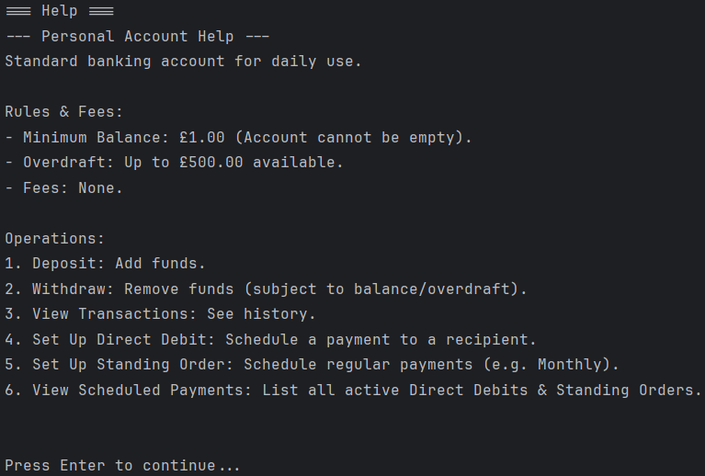
Test Number 2

